Louisiana Tech University
ELEN 479 Automatic Control Systems Lab
Lab 5: System Stability

Task 1
Let’s create a Routh Array in the MATLAB. Consider a system with the characteristic equation:
$$q\left(s\right)=s^{4}+10s^{3}+32s^{2}+37s+20$$
Determine its stability.
Step 1: All the coefficients are positive and there are no missing coefficients.
Step 2: Routh array
$$s^{4}$$ | 1 | 32 | 20
$$s^{3}$$ | 10 | 37 | 0
$$s^{2}$$ | $$\frac{10×32-1×37}{10}=28.3$$ | $$\frac{10×20-1×0}{10}=20$$ | 0
$$s^{1}$$ | $$\frac{28.3×37-10×20}{28.3}=29.9$$ | $$\frac{28.3×0-10×0}{28.3}=0$$ | 0
$$s^{0}$$ | $$\frac{29.9×20-28.3×0}{29.9}=20$$ | 0 | 0

The elements in the first column are all positive -> system is stable.
Task 2
Figure 1 shows the block diagram of the torsion control plant.
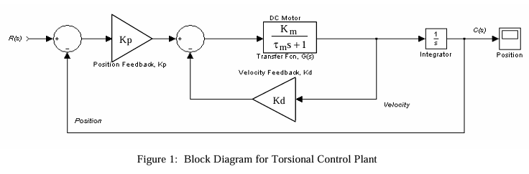
Task 2.1: Starting with the block diagram of the torsional control plant, reduce it to an equivalent closed-loop transfer function. Assume $K_{m}=τ_{m}=1$.
Reference Solution: $\frac{K_{p}}{s^{2}+\left(1+K_{d}\right)s+K_{p}}$

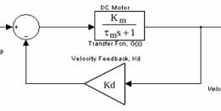
For $K_{m}=τ_{m}=1$.
$$\frac{\frac{1}{s+1}}{1+\frac{Kd}{s+1}}=\frac{\frac{1}{s+1}}{\frac{s+1+Kd}{s+1}}=\frac{1}{s+1+Kd}$$
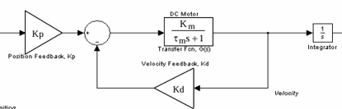
$$Kp×\frac{1}{s+1+Kd}×\frac{1}{s}=\frac{Kp}{s^{2}+\left(1+Kd\right)s}$$

$$\frac{\frac{Kp}{s^{2}+\left(1+Kd\right)s}}{1+\frac{Kp}{s^{2}+\left(1+Kd\right)s}}=\frac{\frac{Kp}{s^{2}+\left(1+Kd\right)s}}{\frac{s^{2}+\left(1+Kd\right)s+Kp}{s^{2}+\left(1+Kd\right)s}}=\frac{Kp}{s^{2}+\left(1+Kd\right)s+Kp}$$

Task 2.2: Apply the Routh-Hurwitz criterion to the denominator of this function to determine the conditions for stability.
$$s^{2}+\left(1+Kd\right)s+Kp$$
$$s^{2}$$ | $$1$$ | $$Kp$$
$$s^{1}$$ | $$1+Kd$$ | $$0$$
$$s^{0}$$ | $$\frac{(1+Kd)Kp-1(0)}{1+Kd}=Kp$$ | $$0$$

The system will be stable for $K_{d}>-1$ and $K_{p}>0$

Task 2.3: Implement Figure 1 in the Simulink. Set the input signal as a step function. Choose values of $K_{p}$ and $K_{d}$ to make the system output stable.
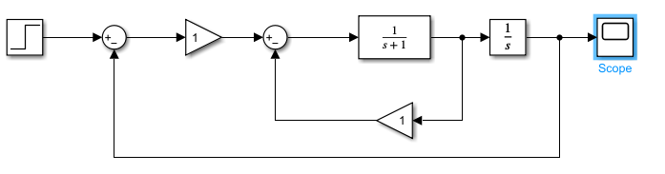
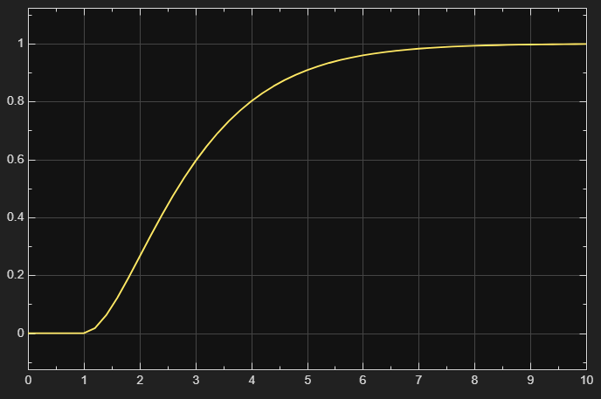
Task 2.4: Implement Figure 1 in the Simulink. Set the input signal as a step function. Choose values of $K_{p}$ and $K_{d}$ to make the system output unstable.
